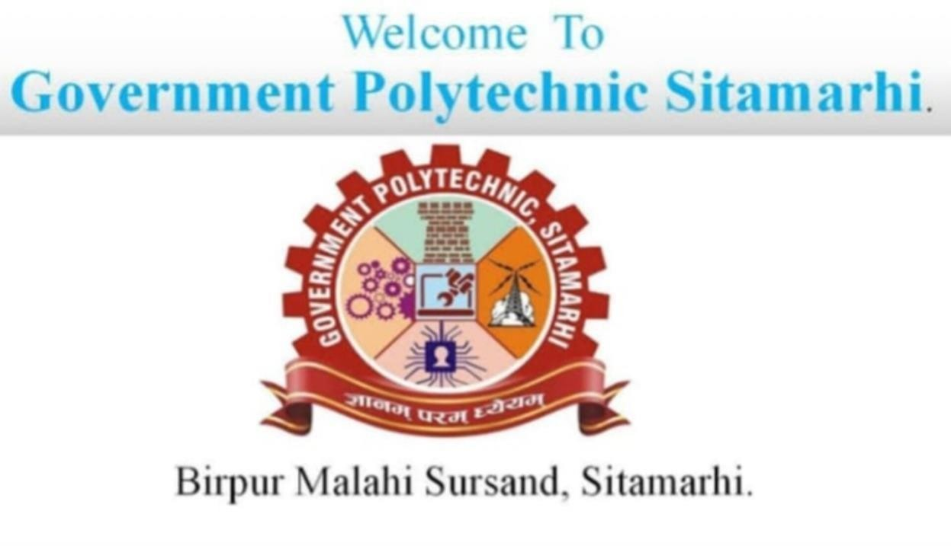

Project Report on
“WEB DEVLOPMENT”
Portfolio, Responsive website, content -form
(Front – end development)
Diploma Year(2024-27)
(Branch – CSE)
__________________________________________________________________ ______________________________________________________

Submitted To: Submitted By:
Satyam kumar sir Rubi kumari

. ACKNOWLEDGEMENT

This “Web Development project” report has been successfully completed with the valuable support and encouragement from many individuals.

First and foremost, I am grateful to God for giving me the strength, inspiration, and perseverance to complete this project.

I would like to express my sincere thanks to my respected teacher, Ujjwal Kumar Singh, for his constant guidance, insightful suggestions, and motivation throughout the development of this project. His mentorship played a crucial role in shaping this project.

I am also thankful to my parents for their unconditional support, encouragement, and trust in me throughout the journey.

Finally, I would like to thank all those who helped me directly or indirectly in completing this project on Web Development – Personal Portfolio Website.

Student’s Name-

Rubi kumari

Introduction

The Personal Portfolio Website project is a Web Development-based project aimed at showcasing an individual’s skills, achievements, projects, and personal information in a structured and interactive manner. This type of website is especially useful for students, professionals, and freelancers to present their online presence and improve career or client opportunities.

In today’s digital era, having a personal portfolio is essential for establishing credibility and online identity. A well-developed portfolio website allows users to display their resume, contact information, and samples of their work such as coding projects, designs, blogs, or photography.

This project is designed using core web technologies such as HTML, CSS, JavaScript, and may include Bootstrap for responsive design. The structure of the website includes multiple sections like Home, About Me, Skills, Projects, Contact, and more.

The primary aim of this project is to learn and implement front-end web development concepts and gain hands-on experience with creating user-friendly, visually appealing, and responsive web pages.

This website can be deployed on platforms like GitHub Pages, Netlify, or Vercel to make it accessible globally. By working on this project, students not only strengthen their design and coding skills but also build a strong foundation for future web development projects.

Abstract

The Personal Portfolio Website is a Web Development project designed to help individuals create a professional online presence. It provides a digital platform where users can showcase their skills, academic background, work experience, personal interests, projects, and contact information in a structured and attractive format.

This project is built using HTML, CSS, JavaScript, and optionally enhanced with Bootstrap and responsive design techniques. The website is fully responsive, which means it adjusts to different screen sizes including mobiles, tablets, and desktops, ensuring a seamless experience for all users.
The main objective of this project is to help individuals highlight their achievements and abilities in a dynamic and interactive way. It simulates the process of designing, developing, and hosting a real-world portfolio website. By creating this project, learners gain hands-on experience in front-end web development, UI/UX design, and personal branding.

The project also introduces basic concepts of version control with GitHub, and how to deploy a website using platforms like GitHub Pages or Netlify. It emphasizes the importance of clean code, modern design practices, and accessibility.

This Personal Portfolio Website not only strengthens a developer’s resume but also acts as a live example of their skills, making it a valuable asset during job interviews, freelancing gigs, and internships.

AIM of this project

The aim of this project is to design and develop a responsive and interactive Personal Portfolio Website using web development technologies. This website serves as a digital resume and portfolio for individuals, allowing them to showcase their skills, qualifications, achievements, and work samples in an organized and appealing format.

Key objectives of this project include:

Creating a user-friendly interface that represents the personality and professionalism of the individual.

Demonstrating proficiency in HTML, CSS, JavaScript, and optionally frameworks like Bootstrap.
Making the website fully responsive for access on various devices including desktops, tablets, and smartphones.

Providing essential sections such as About Me, Projects, Skills, Resume, and Contact.

Allowing easy deployment on platforms such as GitHub Pages or Netlify for public access.

This project not only improves web development skills but also helps in building a strong online presence for career growth.

Main Purpose
The main purpose of developing the Personal Portfolio Website is to create an interactive platform for individuals to professionally present themselves online. Traditionally, individuals used resumes or physical documents to share their background, but with the advancement of the internet, a digital presence has become essential.

This project enables users to showcase their qualifications, skills, achievements, and projects in an organized manner, accessible from anywhere and at any time. It eliminates the limitations of paper-based resumes and allows real-time updates and personalization.

Through this project, users will have an online platform that reflects their personality and talents. It also allows potential employers, clients, or collaborators to learn about the individual without direct contact.

The portfolio website makes it easy for users to manage and present their information, share their work, and receive contact or collaboration requests efficiently. It is a step toward building a professional brand in the digital world

Main Goal
To Create a Personal Online Identity:
The primary goal is to design and develop a personal portfolio website that serves as an individual’s digital identity. It helps showcase the user’s skills, academic background, achievements, and previous work/projects to potential employers, clients, or collaborators.

To Strengthen Web Development Skills:
This project is aimed at improving the practical knowledge of front-end development using technologies like HTML, CSS, JavaScript, and optionally Bootstrap. It encourages hands-on learning through real-time website creation.

To Ensure Mobile Responsiveness:
A major goal is to ensure that the website is responsive, so it looks and functions well across all devices such as desktops, tablets, and mobile phones.
To Provide Easy Access to Information:
The website includes sections like About Me, Projects, Skills, Resume, and Contact, allowing users to display essential details in a structured and accessible format.

To Deploy the Website Live on the Internet:
Hosting the project on platforms like GitHub Pages, Netlify, or Vercel so it can be accessed globally, making it easy to share with others.

To Build a Professional Digital Presence:
The website helps individuals build a strong professional image online, which is essential in today’s tech-driven job market and freelancing world.

Methods
To develop a responsive and functional Personal Portfolio Website, the following methods and steps were followed:

Requirement Analysis:
Identify the purpose of the website, target audience, and the sections needed such as Home, About, Skills, Projects, Contact, etc.

Technology Selection:
Use web technologies such as:

HTML for structure

CSS for styling

JavaScript for interactivity

Bootstrap (optional) for responsive design
Wireframing & Layout Design:
Design a layout or rough sketch of how each section of the website should appear. This helps in organizing content and UI elements efficiently.

Website Development:

Build the homepage with navigation links

Create individual sections/pages like About, Skills, Projects, etc.

Style the site using CSS for fonts, colors, spacing, animations

Add JavaScript for dynamic behavior (like form validation or animations)

Responsiveness Testing:
Ensure the website is mobile-friendly using media queries or frameworks like Bootstrap.

Deployment:
Host the website using platforms like GitHub Pages, Netlify, or Vercel to make it live and accessible publicly.

Maintenance & Updates:
Periodically update the website with new skills, projects, or experiences to keep the content fresh and relevant.

Administrative Modules

In a Personal Portfolio Website, although there is usually no complex admin dashboard like in large web applications, we can define basic administrative functionalities that can be managed by the website owner (the portfolio owner) to keep the site updated and functional. These include:

Admin/User (Owner) Functionalities:

Edit Profile Information:
Ability to update personal details like name, bio, profession, contact details, and social media links in the “About Me” and “Contact” sections.

Add or Update Projects:
Manage the portfolio of projects, including:

Adding new project details

Editing existing project descriptions

Uploading screenshots or live links

Manage Skills Section:
Modify or add new skills (e.g., HTML, CSS, JavaScript, etc.) with progress bars or icons.

Update Resume/CV:
Upload or replace the downloadable resume file.

Handle Contact Form Data:
If the website is connected to a backend or third-party form service (like Formspree or EmailJS), the admin can:

Receive emails from visitors

Monitor and respond to contact form submissions

Theme or Design Customization:
Ability to change the color scheme, fonts, or layout to keep the site modern and aligned with personal branding.

These administrative tasks are typically managed manually by the portfolio owner by editing the source code or using a simple content management setup if integrated. In the future, this could be expanded into a fully dynamic site using technologies like React.js, Node.js, or a CMS (like WordPress or Strapi).

Here in my project there are two types of modules. This module is the main module which performs all the main operations in the system. The major operations in the system are:

BENEFITS OF WEB DEVELOPMENT – PERSONAL PORTFOLIO WE

Creating a Personal Portfolio Website offers several advantages for students, developers, designers, and professionals. Here are the key benefits:

Professional Online Presence
A personal website helps in building a strong professional image. It shows that the individual is serious about their career and has the technical skills to present themselves online.

24/7 Accessibility
Unlike a printed resume, a portfolio website can be accessed anytime from anywhere by employers, clients, or collaborators.

Showcase Skills and Projects
The website allows users to clearly display their technical skills, tools they use, and the projects they’ve worked on with live previews or GitHub links.

Centralized Information
All important information such as About Me, Resume, Skills, Projects, Contact Info is available in one place, making it easy to share.

Improves Technical Skills
Building a portfolio site enhances practical knowledge of HTML, CSS, JavaScript, and responsive design. It also encourages learning deployment, hosting, and code maintenance.

Increased Career Opportunities
Recruiters and clients can discover the site and reach out directly. It acts as a self-marketing tool for jobs, internships, and freelance work.

Customizable and Updatable
The site can be easily updated with new skills, certifications, or projects — keeping it fresh and relevant over time.

Stand Out from the Crowd
A well-designed personal website helps you stand out among others who may rely only on resumes or LinkedIn profiles.

Future Look

The Personal Portfolio Website project has a strong foundation in front-end development, but it also offers great scope for future improvement and advanced implementation. Here’s how this project can be expanded in the future:

Convert to a Dynamic Website:
Currently static, the portfolio can be enhanced using back-end technologies like Node.js, PHP, or Python (Django/Flask) to manage dynamic content.

Add CMS Integration:
A Content Management System (CMS) like WordPress, Strapi, or Sanity can be integrated to allow the user to update project information or content without editing the code.

Theme Customizer:
Implement a front-end theme switcher (light/dark mode) or custom color selectors for personalized design.

Add Blog Functionality:
A blog section can be included where the user can publish articles, tutorials, or personal insights related to tech or career journey.

Analytics Integration:
Tools like Google Analytics can be added to track visitor stats, user engagement, and behavior on the site.

SEO Optimization:
Improve search engine visibility with proper meta tags, structured data, and mobile optimization.

Progressive Web App (PWA):
Convert the site into a PWA to enable offline access, mobile-like behavior, and app installation features.

AI Chatbot Integration:
Add a simple chatbot or contact assistant to answer common questions or guide users.

Multilingual Support:
Add language switcher functionality for a global audience.

Custom Dashboard (Admin Panel):
Develop a secure admin dashboard where the user can log in and edit content like projects, skills, and personal info in real-time.
These future enhancements will not only add value to the portfolio website but also demonstrate the developer’s ability to build scalable, user-friendly, and professional-grade web applications.

Conclusion

The Personal Portfolio Website project has been successfully designed and developed using modern web development technologies such as HTML, CSS, and JavaScript. The project has achieved its goal of creating a professional and interactive platform for individuals to present their personal, academic, and professional details online.

Through this project, essential web development skills have been implemented, including layout
structuring, styling, responsive design, and user interface creation. It also provided an opportunity to understand the importance of digital presence in today’s competitive and technology-driven world.

The website acts as a digital resume that can be easily updated, shared, and accessed globally. It enables users to stand out from the crowd and attract better career opportunities by showcasing their skills and work in an organized and visually appealing format.

In the future, this project can be expanded by integrating advanced features such as a content management system, contact form handling, blog section, or deployment as a full-stack web application.

Overall, this project not only enhances technical knowledge but also helps in building a strong foundation for professional branding and online identity.

Reference

During the development of this Web Development project – Personal Portfolio Website – various online platforms and learning resources were used for guidance and support. The key references include:

W3Schools – Comprehensive tutorials on HTML, CSS, JavaScript https://www.w3schools.com

MDN Web Docs (Mozilla Developer Network) – Web standards and best practices https://developer.mozilla.org

YouTube Tutorials (CodeWithHarry, Thapa Technical, Web Dev Simplified, etc.) – Practical guidance on building responsive and modern websites https://www.youtube.com

GitHub – For code version control, project hosting, and portfolio deployment https://github.com

Bootstrap Documentation – For responsive design and layout https://getbootstrap.com

Google Fonts & Font Awesome – For adding professional typography and icons https://fonts.google.com
https://fontawesome.com

Netlify & GitHub Pages – Platforms used for deploying portfolio websites https://www.netlify.com
https://pages.github.com

Stack Overflow – For problem-solving and debugging issues https://stackoverflow.com

Source Code

Portfolio-Website/
│
├── index.html → Main homepage
├── about.html → About Me page
├── projects.html → Projects showcase
├── contact.html → Contact form and details
│
├── css/
│ └── style.css → Main stylesheet
│
├── js/
│ └── script.js → Optional interactivity (e.g., form validation, animations) │
├── images/
│ └── profile.jpg → Profile picture and other visuals
│
└── resume/
└── resume.pdf → Downloadable resume file

Screenshort

